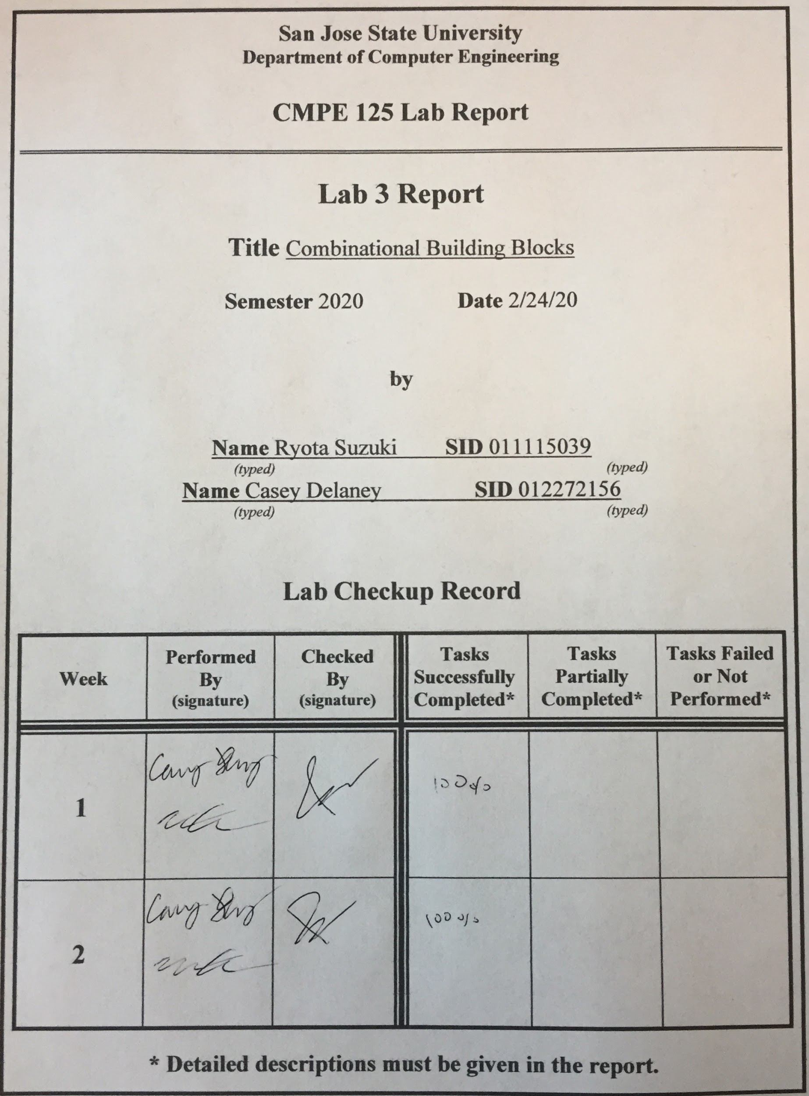

**Introduction**

The purpose of this lab is to familiarize ourselves with the basic combinational building blocks and design/verification /validation flow and the EDA tool. Our task was to build a priority encoder, a 4 bit right shift/rotator, and a 4 bit ALU using verilog language and later implement it on the Basys3 board.

**Design methodology**

The first task was to build a priority encoder, which detects the highest bit that is turned on and returns it as a 3 digit binary on the LED. In our build we used 8 switches, which had a weight from 0 to 7 from right to left. We also had an LED that showed if the switch configuration was valid, the LED will only be off when all switches are turned off. There are multiple methods to design a 4 bit priority encoder. The three methods we used to build it were using if, case, and loop functions inside the design sources. The source codes are provided below in the appendix. Then we compared our results to the self_checking testbench to make sure our design was working as intended. The truth table of the priority encoder is provided below.

|  |  |  |  |
| --- | --- | --- | --- |
| **Switch configuration** | **Binary representation** | **Decimal representation** | **isValid** |
| 1 x x x x x x x | 0 1 1 1 | 7 | 1 |
| 0 1 x x x x x x | 0 1 1 0 | 6 | 1 |
| 0 0 1 x x x x x | 0 1 0 1 | 5 | 1 |
| 0 0 0 1 x x x x | 0 1 0 0 | 4 | 1 |
| 0 0 0 0 1 x x x | 0 0 1 1 | 3 | 1 |
| 0 0 0 0 0 1 x x | 0 0 1 0 | 2 | 1 |
| 0 0 0 0 0 0 1 x | 0 0 0 1 | 1 | 1 |
| 0 0 0 0 0 0 0 1 | 0 0 0 0 | 0 | 1 |
| 0 0 0 0 0 0 0 0 | 0 0 0 0 | 0 | 0 |

*Table1: Priority encoder truth table*

The next task was to build a 4 bit right shift/rotator. We have four switches for the initial 4 bit and LED will turn on corresponding to it. Then we gave the board 3 control pins, 8 total combinations for the different shift/rotates. The operations corresponding to the control pins are shown below on the table.

|  |  |  |  |
| --- | --- | --- | --- |
| **Ctrl [2:0]** | **Operation** | **Input** | **Output** |
| 000 | Pass | a b c d | a b c d |
| 001 | Shift right 1 bit | a b c d | 0 a b c |
| 010 | Shift right 2 bits | a b c d | 0 0 a b |
| 011 | Shift right 3 bits | a b c d | 0 0 0 a |
| 100 | Shift right 4 bits | a b c d | 0 0 0 0 |
| 101 | Rotate right 1 bit | a b c d | d a b c |
| 110 | Rotate right 2 bits | a b c d | c d a b |
| 111 | Rotate right 3 bits | a b c d | b c d a |

*Table2: Shifter/rotator truth table*

The last task we were assigned was to build a 4 bit ALU. The 4 bit ALU has two sets of 4 switches for the comparison variables and a total of 3 control pins. One pin is used to choose between logic/arithmetic comparison. When in the logic comparison, we have 4 different options we can choose from the 2 control pins we have, which are bitwise negation, bitwise AND, bitwise XOR, and bitwise OR. For the arithmetic comparisons, we have decrement, addition, subtraction, and increment. After performing the arithmetic comparisons, we set functions to set carry flag to 1 when addition goes beyond 4 bit, and a zero-flag set to 1 when a comparison results in a 0.

|  |  |  |
| --- | --- | --- |
| **S0 S1** | **M (logic=0, arithmetic=1)** | **Operation** |
| 0 0 | 0 | Bitwise negation |
| 0 1 | 0 | Bitwise AND |
| 1 0 | 0 | Bitwise XOR |
| 1 1 | 0 | Bitwise OR |
| 0 0 | 1 | Decrement |
| 0 1 | 1 | Addition |
| 1 0 | 1 | Subtraction |
| 1 1 | 1 | Increment |

*Table3: 4 bit ALU truth operations*

**Simulation Results**

For the priority encoder, the in_tb[7:0] represents the weight of each switch. Since we tested using case, if, and for methods, we have three simulation tests. We can see valid is only 0 when all 8 switches are off. The output for all three methods are shown in decimal.

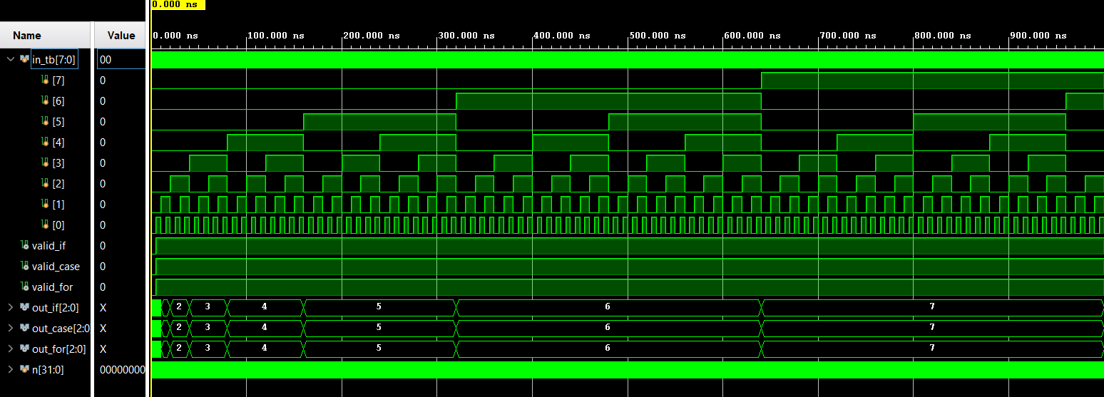

*Figure1: Priority encoder waveform*

The figure below is split in three sections. The top section shows the output before any rotation or shifts. The second row shows the shift/rotate simulation using our design while the third row shows the expected simulation. The left half of row 2 and 3 shows a shifter function, while the right half shows a rotate function.

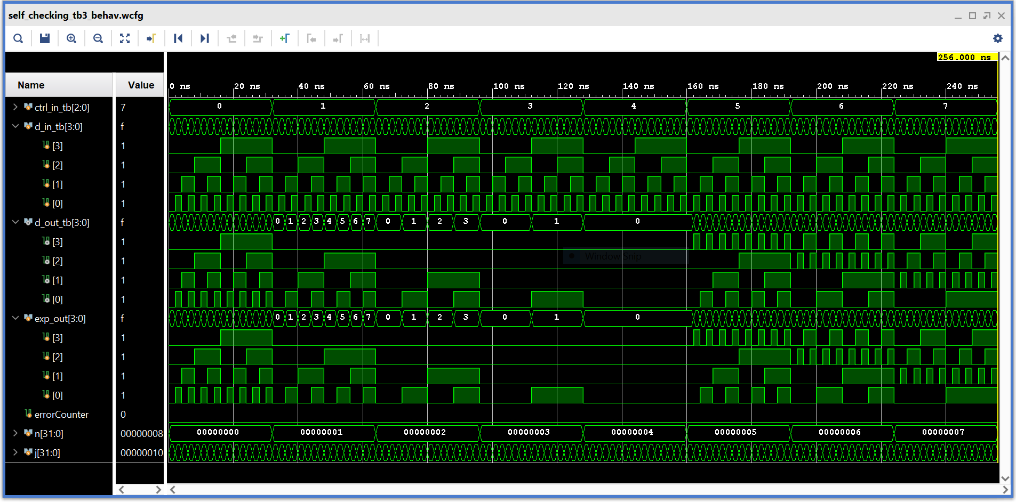

*Figure2: Shifter/rotator waveform*

In figure 3 below, our self checking test bench shows the simulation results of our ALU. The testbench goes through each combination for S0, S1, and M and also goes throiugh each combination of the possible inputs. The zero, overflow flags and the error count are also shown. Since there are so many possible combinations, the array of different inputs can be very difficult to see, but the out_tb waveform makes it easier to see the results.

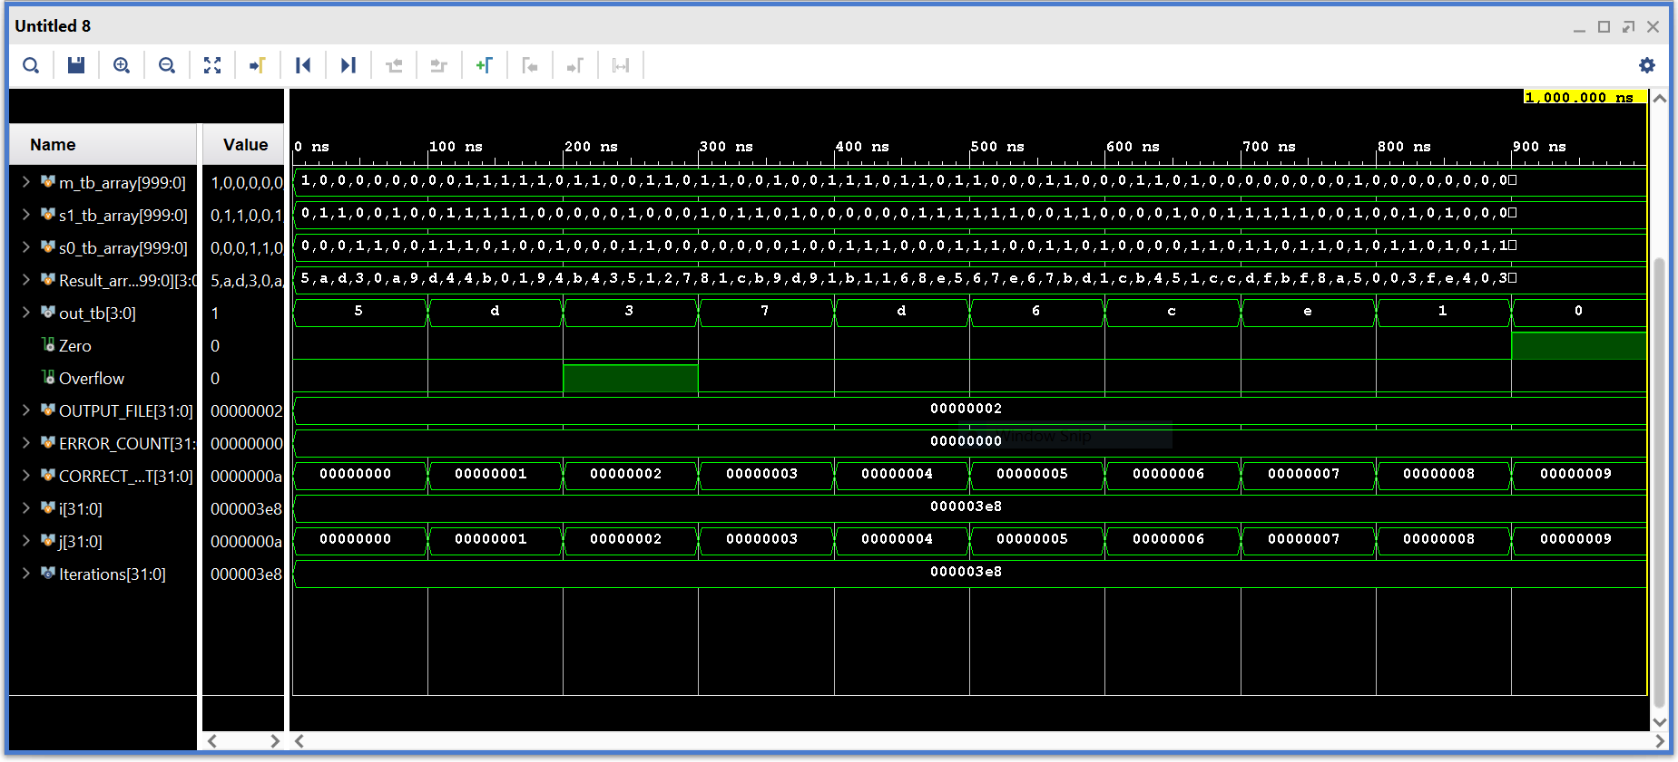

*Figure3: 4bit ALU waveform*

**FPGA Validation**

Once the modules were created, we generated the bitstream file to load onto the FPGA board and validate our file. Figures 4 and 5 show the results from the priority encoder. The rightmost 8 switches on the board are used to control the inputs, with the leftmost of these switches being the most significant bit. The three leds on the rightmost side of the board represent the 3 bit output, and the 5th led from the right side of the board represents if there is an input. The 8 switches are decoded into the 3 LED output, with the output being dependent on the leftmost switch.

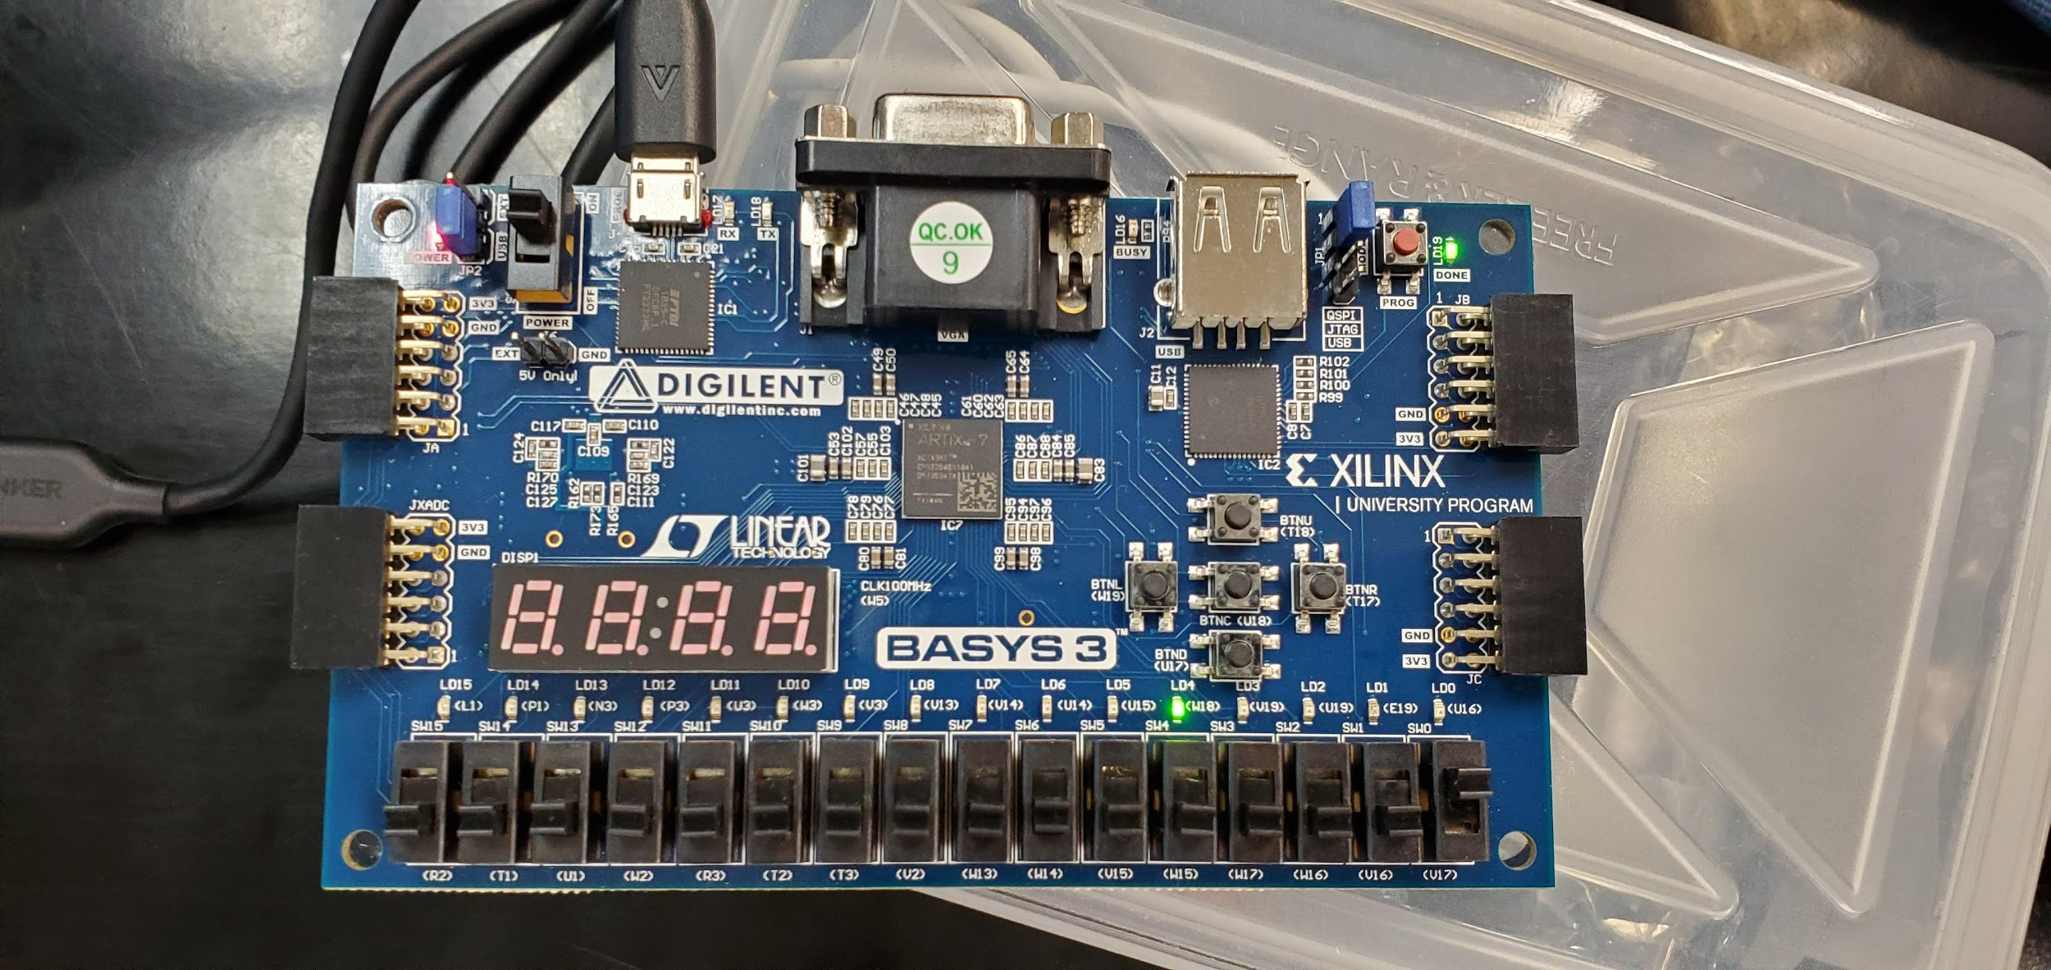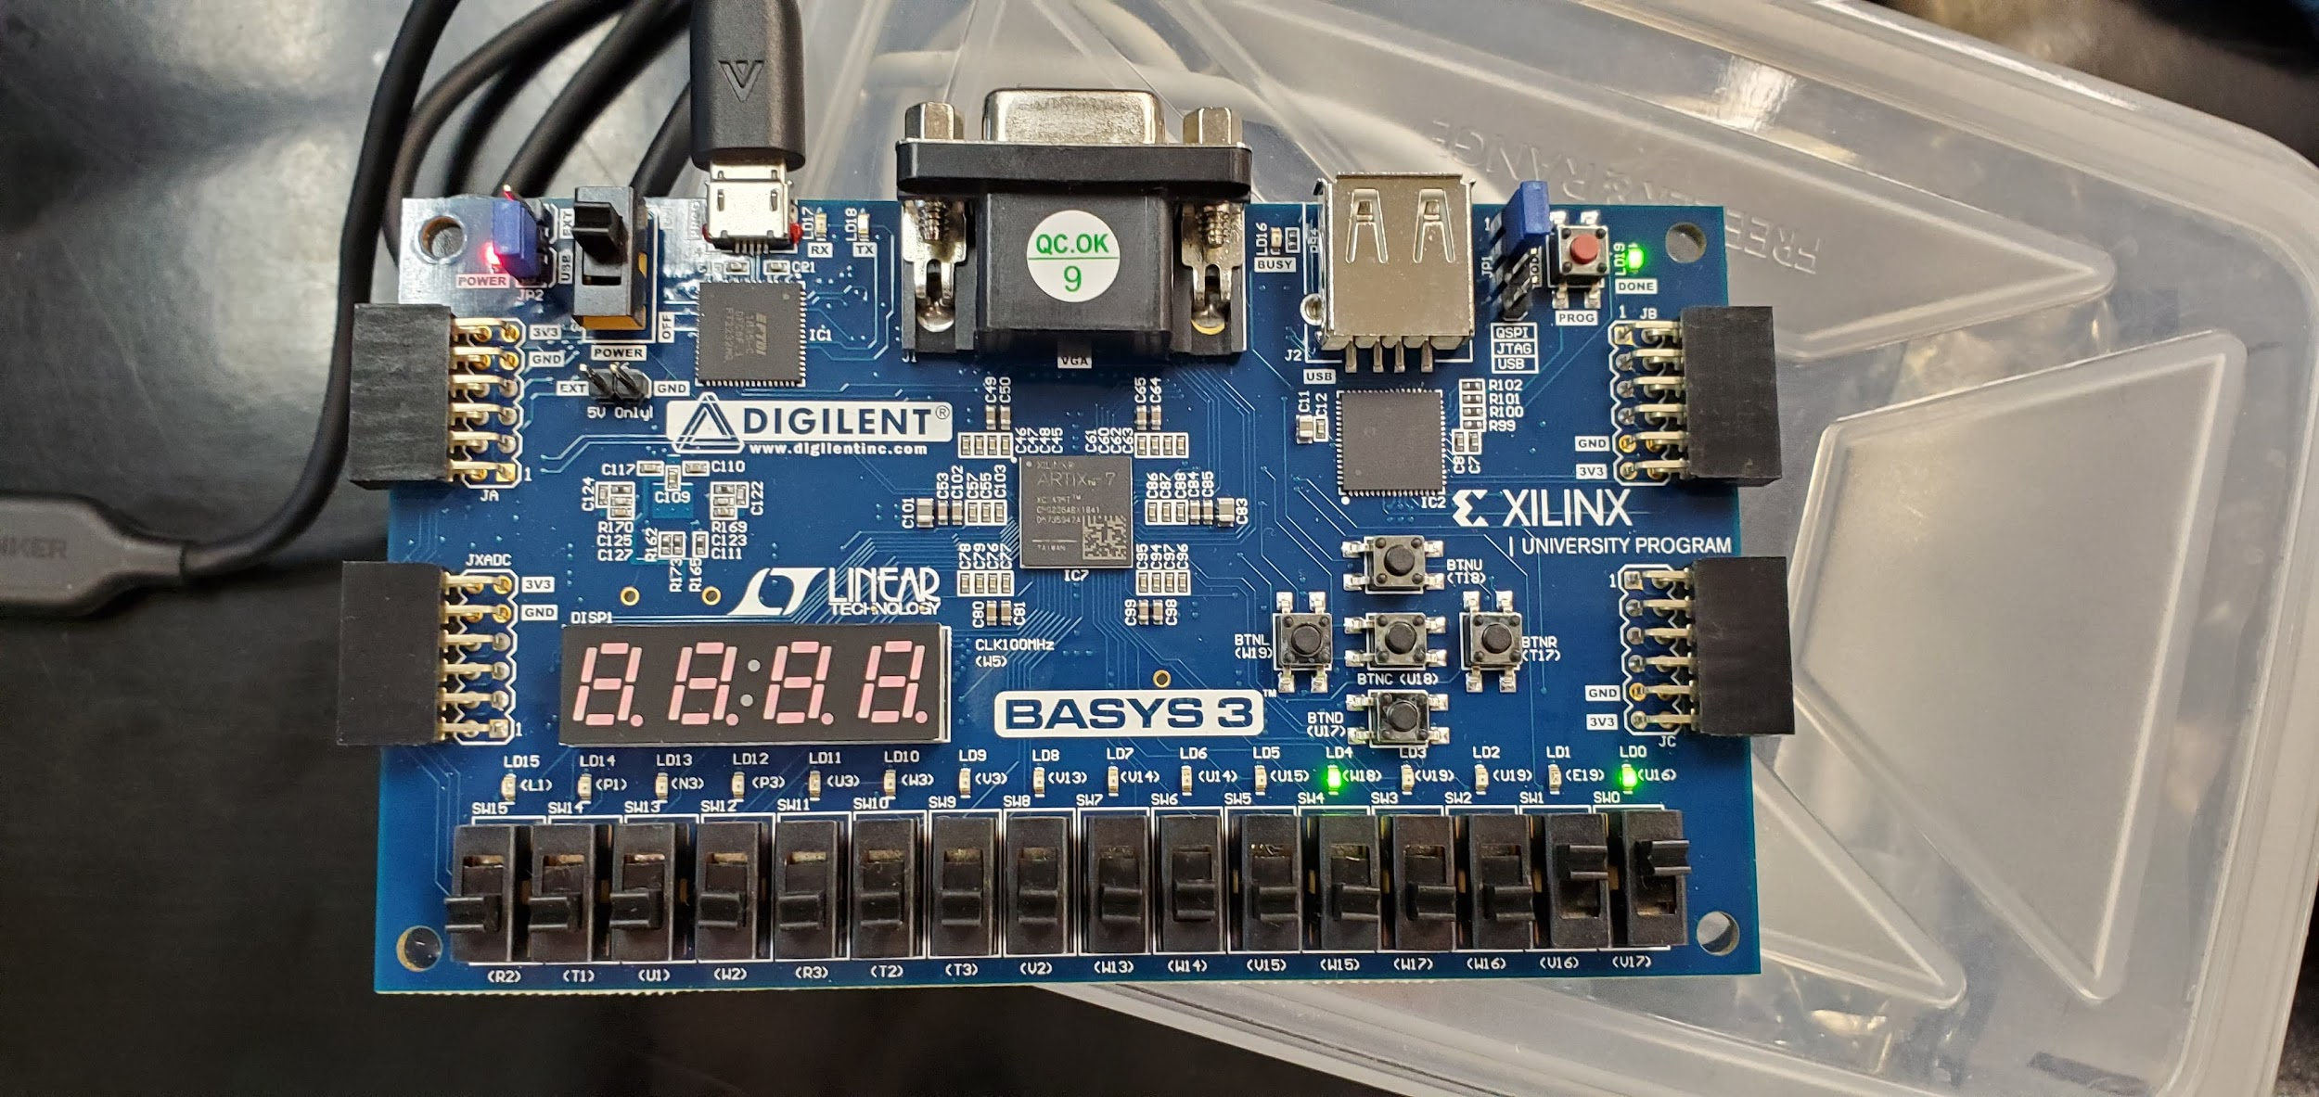

*Figure4: Left shows switch[0] on. Right shows switch [0] and [1] on*

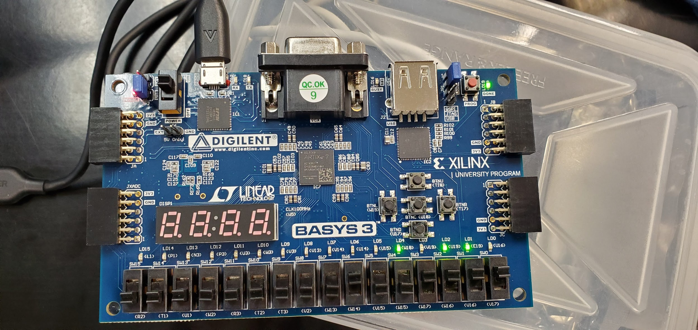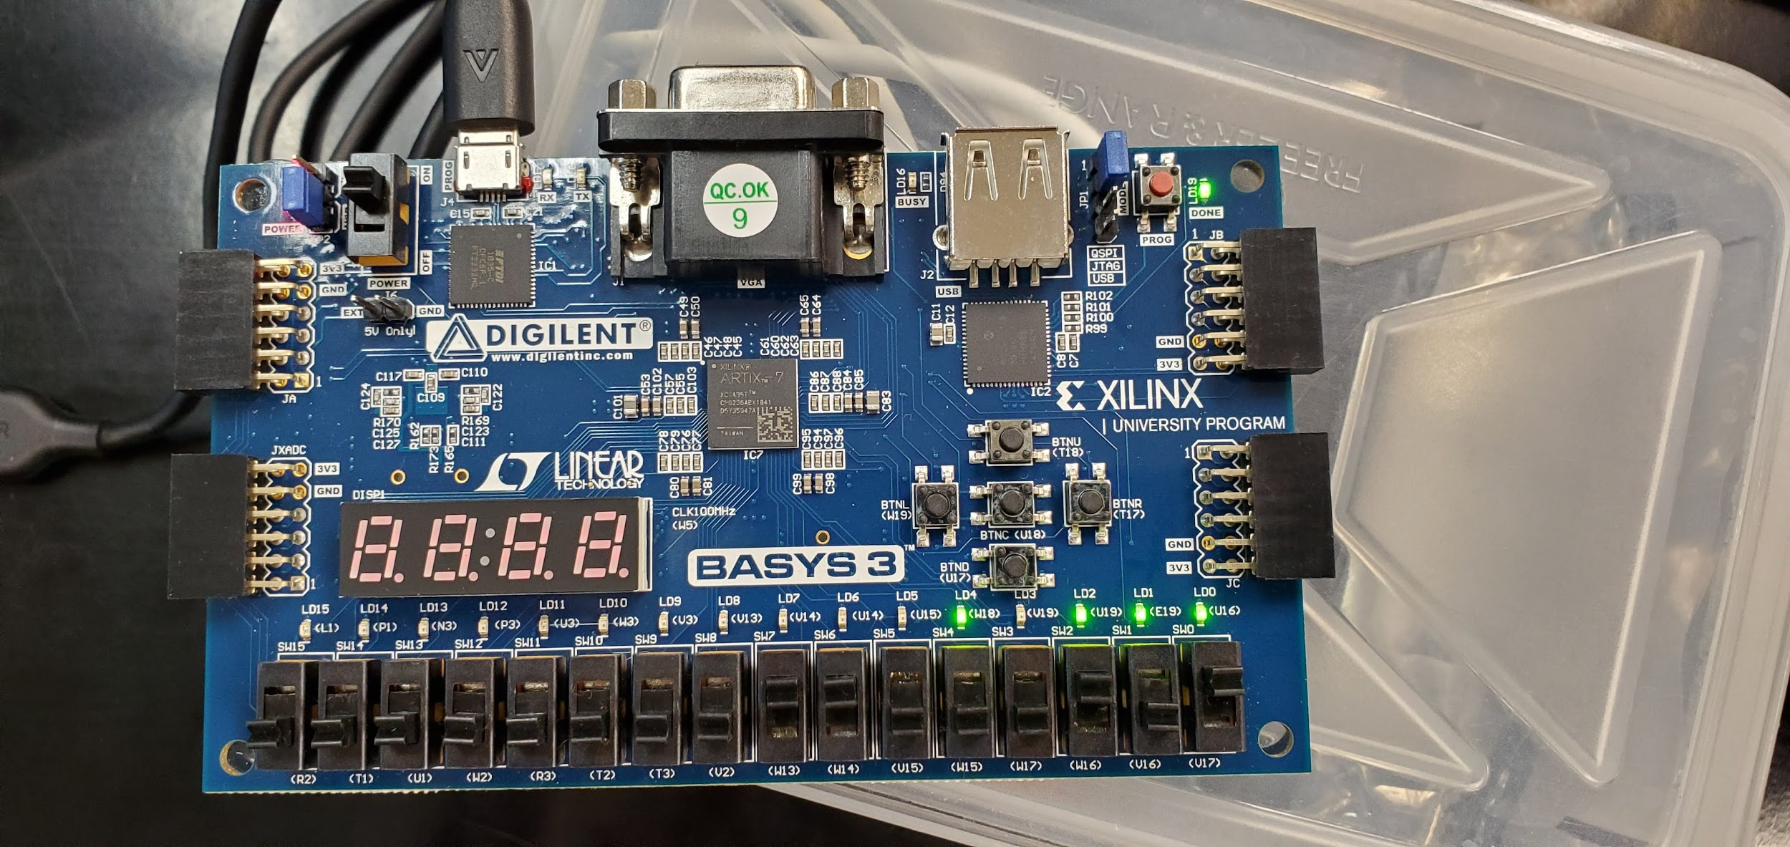

*Figure5: Left shows switch[0:3] and [7] on. Right shows switch [0], [2], [6], and [7] on*

In figures 6 through 8, the results from the shifter/rotator file are shown on our FPGA board. The three switches on the rightmost side of the board represent the Ctrl switches. Refer to the constraints file in the appendix to see the configuration. Switches W13 through W15 were used as the input switches with the corresponding LED output shown above them. The figure descriptions describe each operation. Refer to table 2 for the truth table.

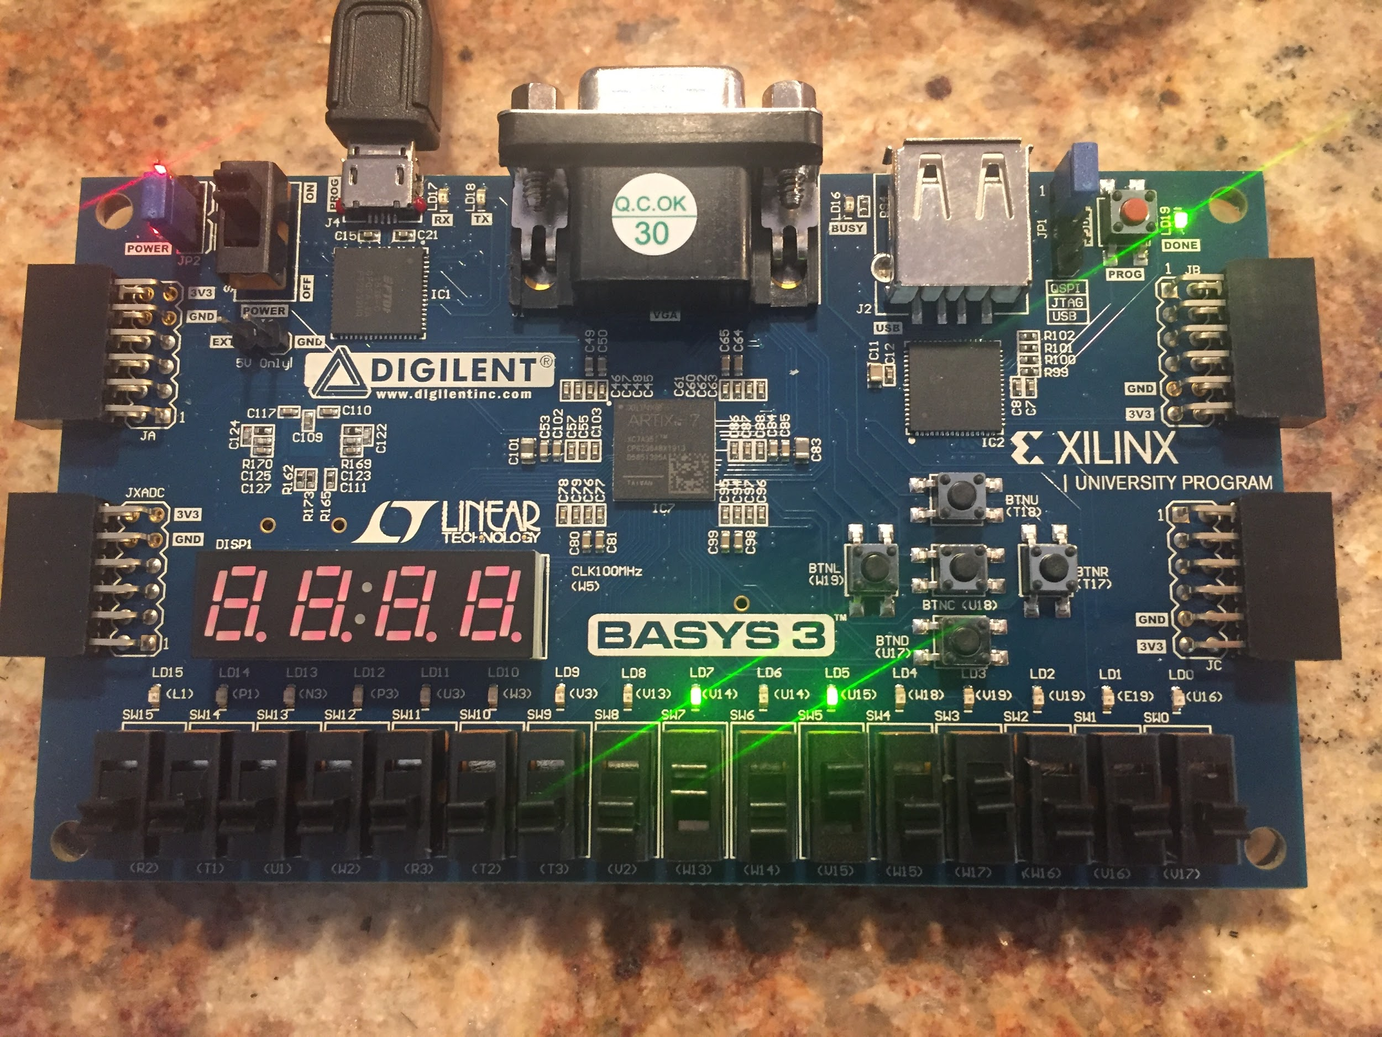

*Figure6: Input is 1010 and Ctrl is 000, so the output is 1010*

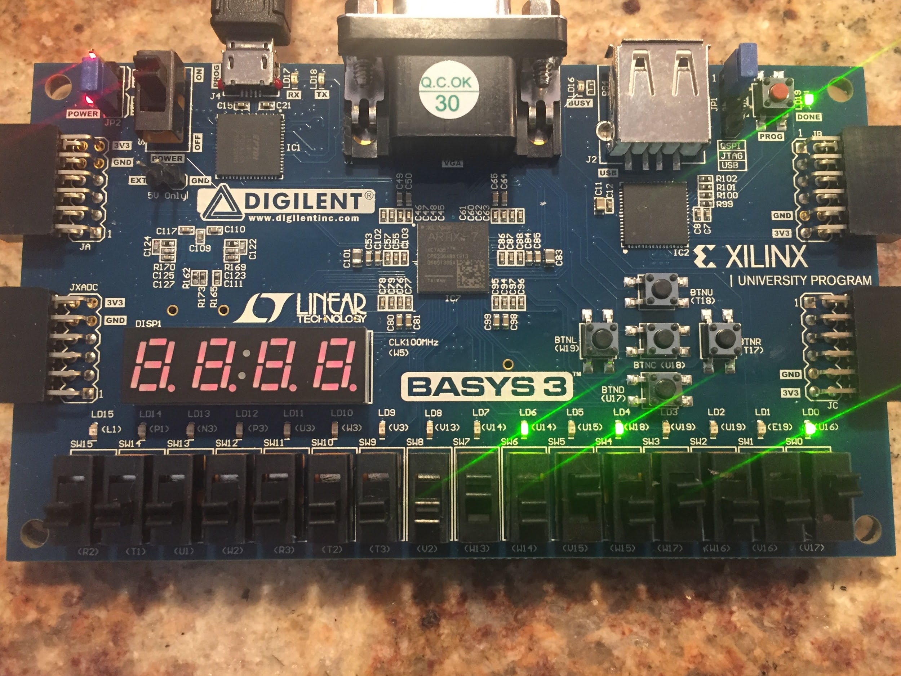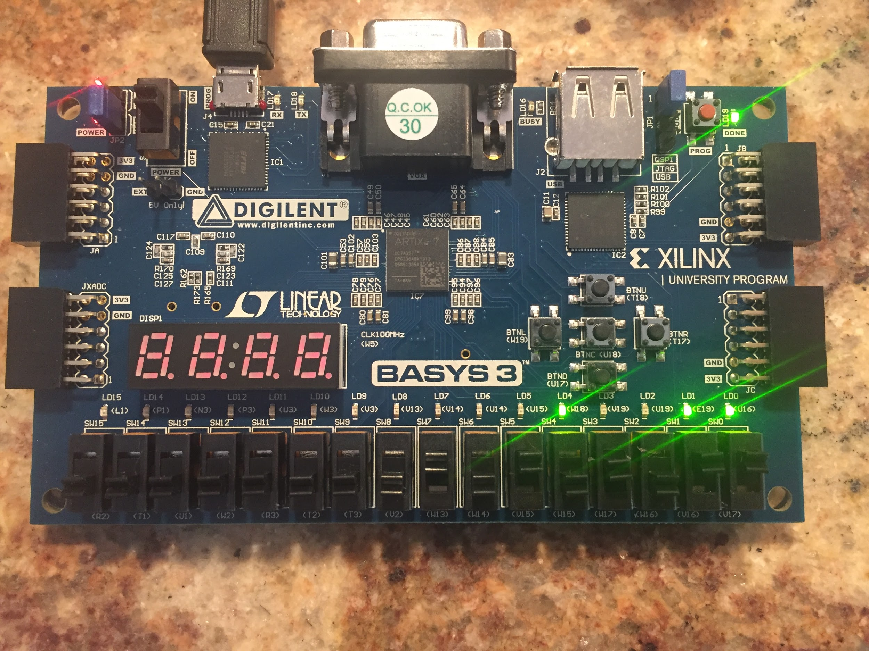

*Figure7: Left shows Ctrl is 001, therefore the input is shifted right by 1 bit. Right shows Ctrl is 011, therefore the input is shifter right by 3 bits*

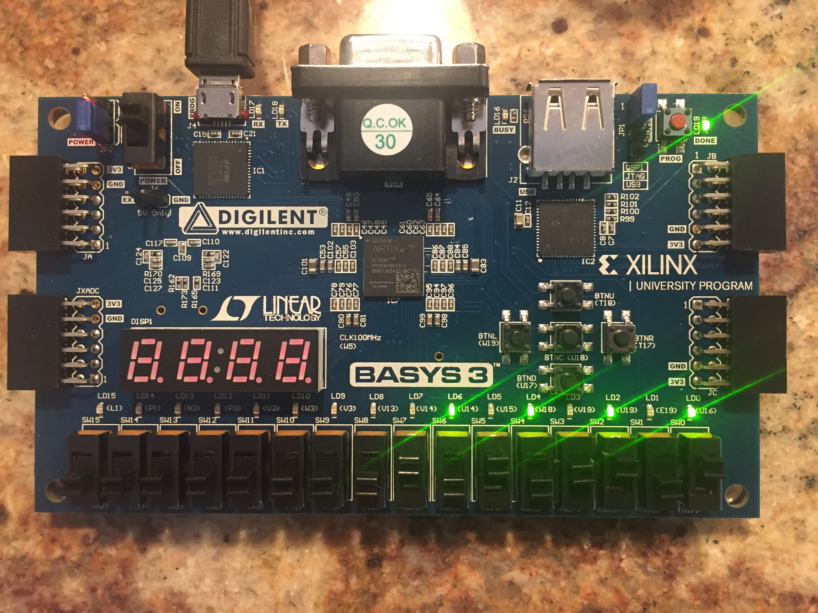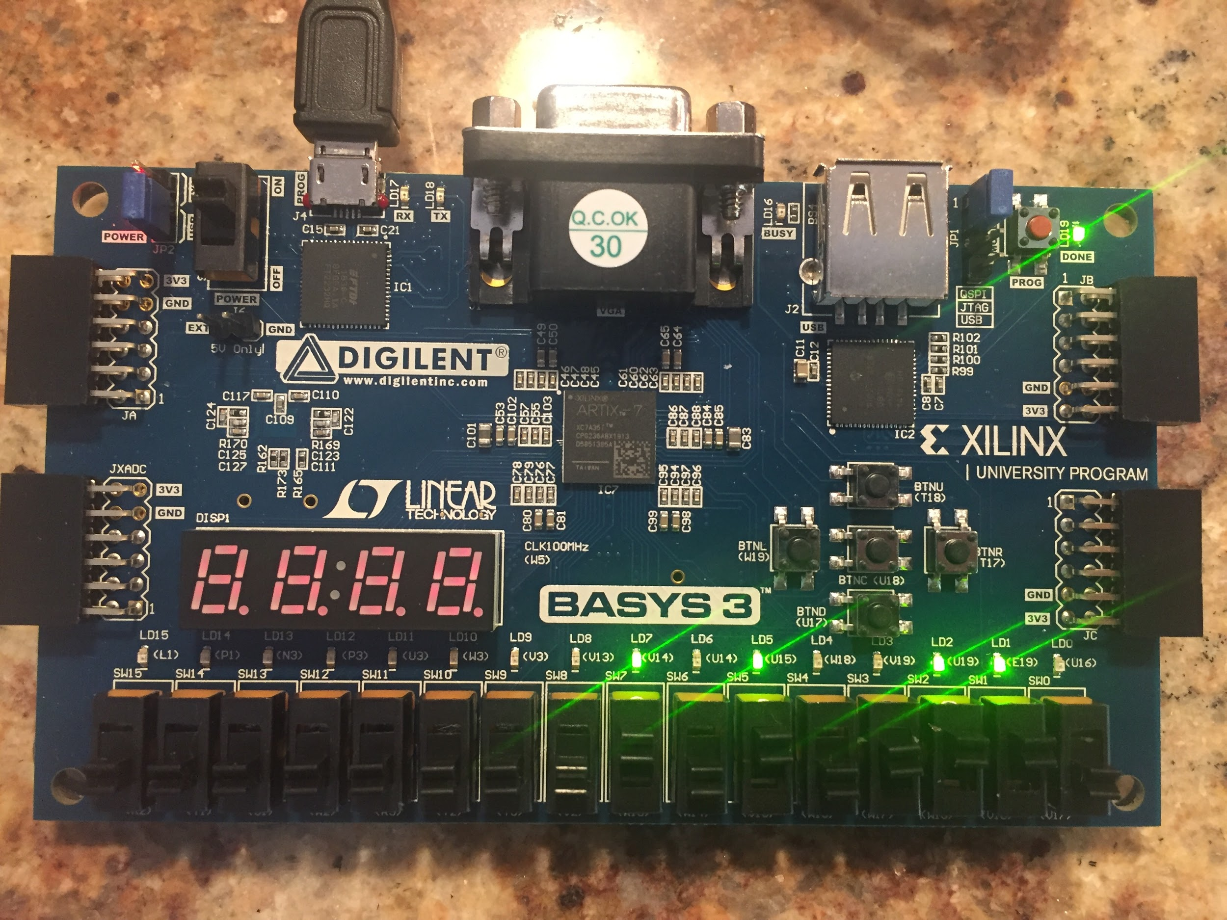

*Figure8: Left shows Ctrl is 101, therefore the input is rotated right by 1 bit. Right shows Ctrl is 110, therefore the input is rotated right by 2 bits*

Figures 9 through 11 show the results from the ALU file. The 3 rightmost switches are used as the control pins in the order of S0, S1, M from left to right. The rightmost 4 LEDS represent the output LEDS from the operations. Switches R3 through W15 represent inputs B and A respectively. Note, the input from A is shown above the switches for A using the LEDs, but the inputs for B are not shown above input switches B because these were used for the zero and overflow flags. W3 (6th from left) is the zero flag LED while U3 (5th from left) is the overflow flag LED.

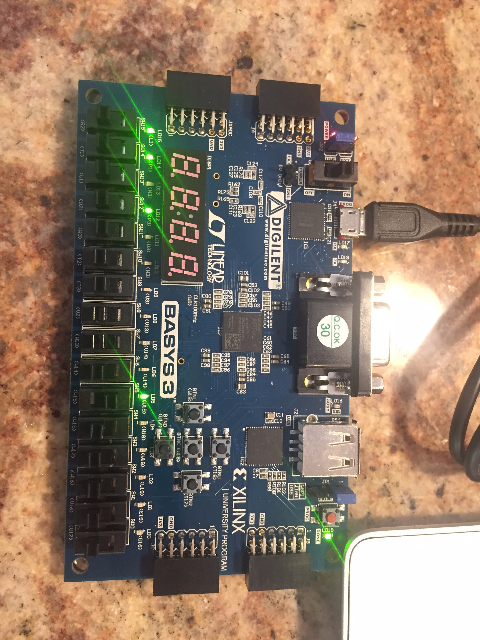

*Figure9: Left shows Ctrl is 000, therefore this is an inverter operation. The input is 0010, so the output (leftmost LEDs) is 1101.*

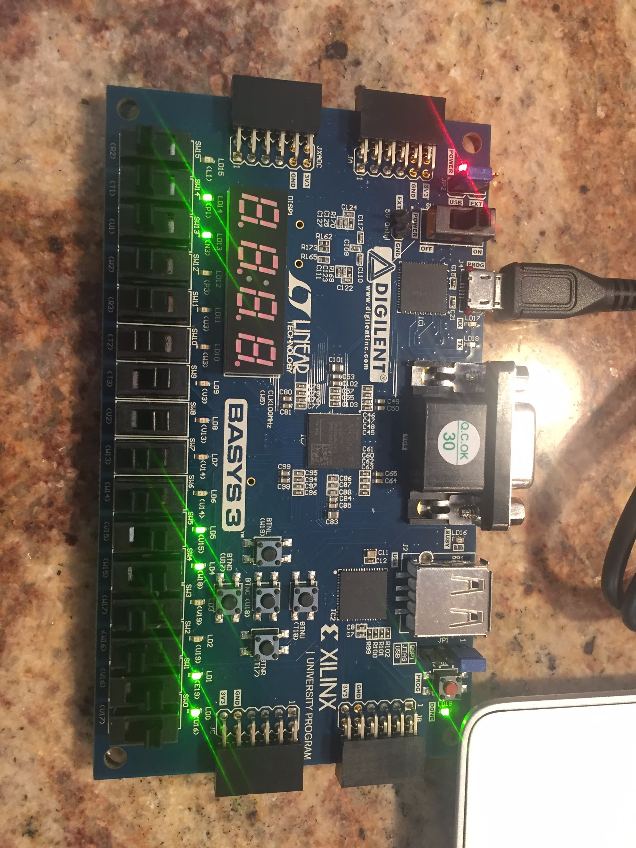

*Figure10: Left shows Ctrl is 011, therefore this is an addition operation. A is 0011 and B is also 0011. The output is 0110 when these are added*

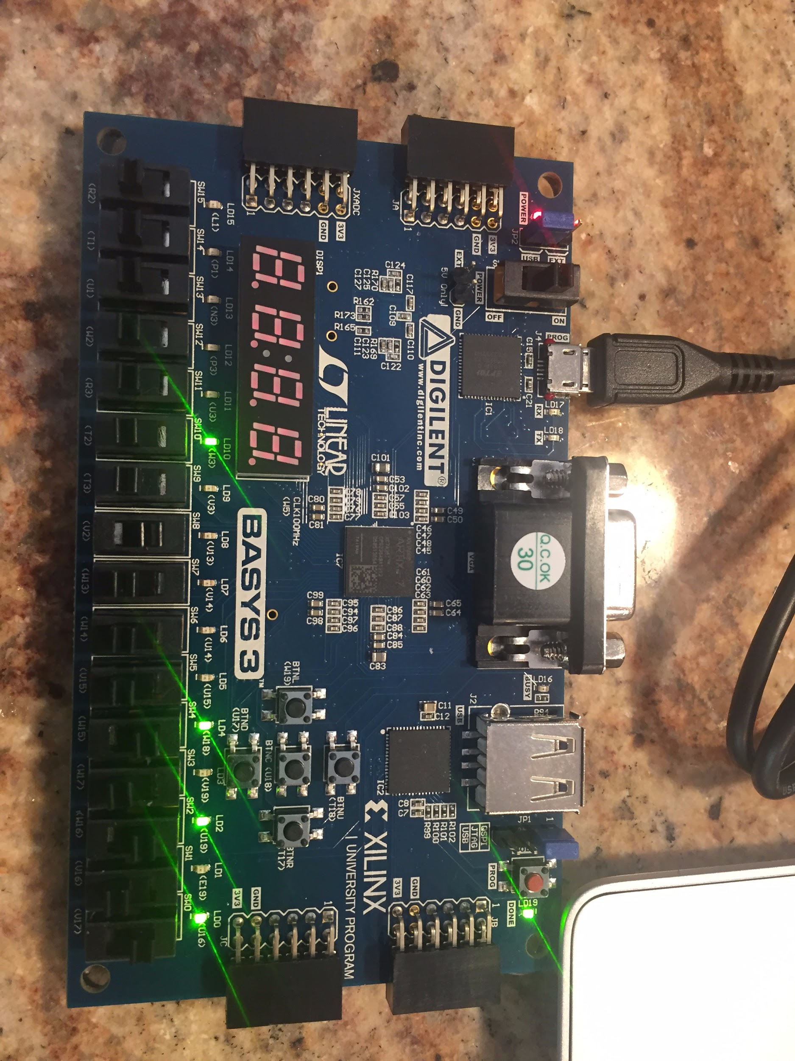

*Figure11: Left shows Ctrl is 101, therefore this is an subtraction operation. A is 0001 and B is also 0001. The output is 0000, so the 6th LED from the left lights up which is the zero flag.*

**Conclusion**

The purpose of this lab is to familiarize ourselves with the basic combinational building blocks and design/verification /validation flow and the EDA tool. We successfully designed the priority encounter, shifter/rotator, and the 4bit ALU. Then we ran the simulation to check if the waveforms matched. At the end we implemented the design onto our BASYS3 FPGA board and validated our results.

**Appendix**

Modules

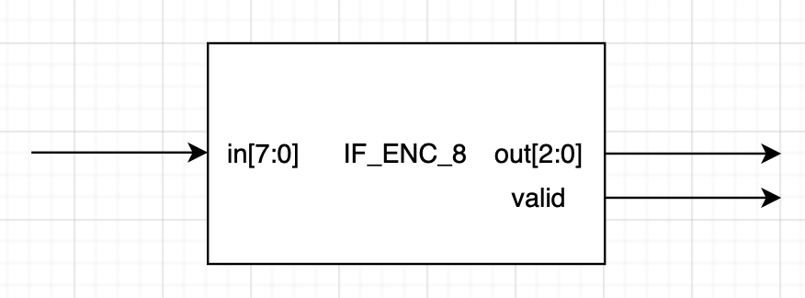

Figure12: IF_ENC_8 top level design

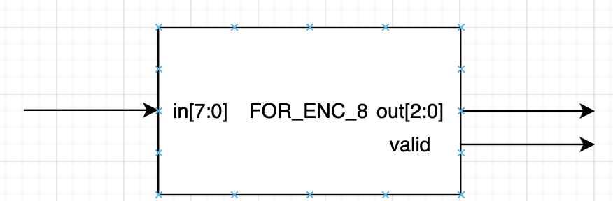

Figure13: FOR_ENC_8 top level design

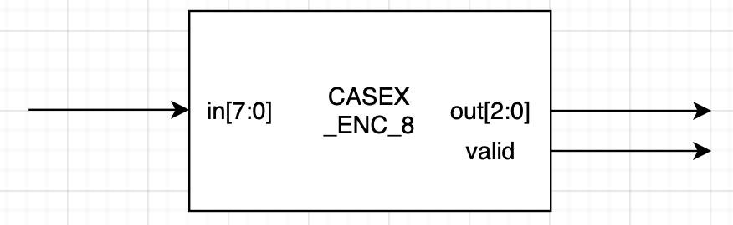

Figure14: CASEX_ENC_8 top level design

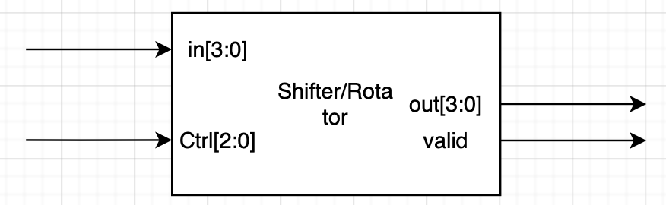

Figure 15: Shifter/Rotator top level design

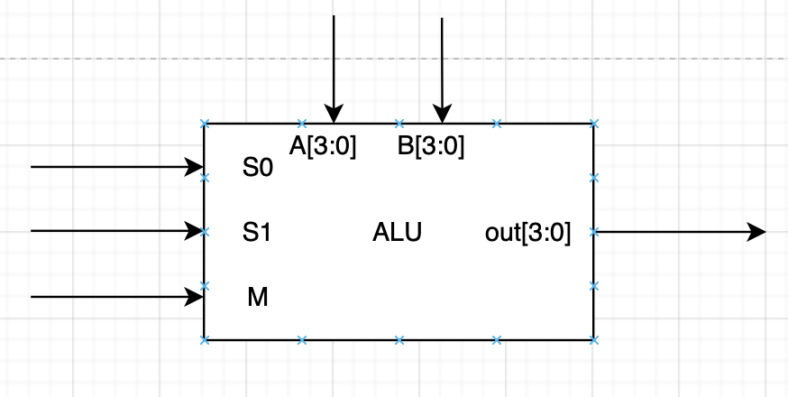

Figure 16: ALU top level design

Priority Encoder Code

|  |
| --- |
| **priority_encoder_fpga.v** |
| `timescale 1ns / 1ps  module priority_encoder_fpga(  input wire clk100MHz,  input wire rst,  input wire [7:0] switch,  output wire [2:0] LED,  output wire ISvalid  );    wire DONT_USE;  wire clk_5KHz;    IF_ENC8_3 MYIF(  .in (switch),  .out (LED),  .valid (ISvalid)  );    clk_gen CLK (  .clk100MHz (clk100MHz),  .rst (rst),  .clk_4sec (DONT_USE),  .clk_5KHz (clk_5KHz)  );    endmodule |

|  |
| --- |
| IF_ENC8_3.v |
| `timescale 1ns / 1ps  module IF_ENC8_3(  input wire [7:0] in,  output reg [2:0] out,  output reg valid  );    always @ (in)  begin  valid = 1;  if(in[7]) out = 3'b111;  else if(in[6]) out = 3'b110;  else if(in[5]) out = 3'b101;  else if(in[4]) out = 3'b100;  else if(in[3]) out = 3'b011;  else if(in[2]) out = 3'b010;  else if(in[1]) out = 3'b001;  else if(in[0]) out = 3'b000;  else  begin  valid = 0;  out = 3'bx;  end  end  endmodule |

|  |
| --- |
| CASEX_ENC8_3.v |
| module CASEX_ENC8_3(  input wire [7:0] in,  output reg [2:0] out,  output reg valid  );  always @(in)  begin  valid = 1;  casex(in)  8'b 1xxxxxxx: out = 7;  8'b 01xxxxxx: out = 6;  8'b 001xxxxx: out = 5;  8'b 0001xxxx: out = 4;  8'b 00001xxx: out = 3;  8'b 000001xx: out = 2;  8'b 0000001x: out = 1;  8'b 00000001: out = 0;  default:  begin  valid = 0;  out = 3'bx;  end  endcase  end  endmodule |

|  |
| --- |
| FOR_ENC8_3.v |
| module FOR_ENC8_3(  input wire [7:0] in,  output reg [2:0] out,  output reg valid  );  integer N;  always @ (in)  begin  valid = 0;  out = 3'bx;  for(N = 0; N < 8; N = N + 1)  if(in[N])  begin  valid = 1;  out = N;  end  end    endmodule |

|  |
| --- |
| priority_encoder.xdc |
| # Clock signal  set_property -dict {PACKAGE_PIN W5 IOSTANDARD LVCMOS33} [get_ports {clk100MHz}];  create_clock -add -name sys_clk_pin -period 10.00 -waveform {0 5} [get_ports {clk100MHz}];  # Switches  set_property -dict {PACKAGE_PIN V17 IOSTANDARD LVCMOS33} [get_ports {switch[0]}]; # Switch 0  set_property -dict {PACKAGE_PIN V16 IOSTANDARD LVCMOS33} [get_ports {switch[1]}]; # Switch 1  set_property -dict {PACKAGE_PIN W16 IOSTANDARD LVCMOS33} [get_ports {switch[2]}]; # Switch 2  set_property -dict {PACKAGE_PIN W17 IOSTANDARD LVCMOS33} [get_ports {switch[3]}]; # Switch 3  set_property -dict {PACKAGE_PIN W15 IOSTANDARD LVCMOS33} [get_ports {switch[4]}]; # Switch 4  set_property -dict {PACKAGE_PIN V15 IOSTANDARD LVCMOS33} [get_ports {switch[5]}]; # Switch 5  set_property -dict {PACKAGE_PIN W14 IOSTANDARD LVCMOS33} [get_ports {switch[6]}]; # Switch 6  set_property -dict {PACKAGE_PIN W13 IOSTANDARD LVCMOS33} [get_ports {switch[7]}]; # Switch 7    # LEDs  set_property -dict {PACKAGE_PIN U16 IOSTANDARD LVCMOS33} [get_ports {LED[0]}]; # LED 0  set_property -dict {PACKAGE_PIN E19 IOSTANDARD LVCMOS33} [get_ports {LED[1]}]; # LED 1  set_property -dict {PACKAGE_PIN U19 IOSTANDARD LVCMOS33} [get_ports {LED[2]}]; # LED 2  set_property -dict {PACKAGE_PIN V19 IOSTANDARD LVCMOS33} [get_ports {ISvalid}]; # valid |

|  |
| --- |
| self_checking_tb1.v |
| `timescale 1ns / 1ps  module self_checking_tb1;  reg [7:0] in_tb;  wire valid_if, valid_case, valid_for;  wire [2:0] out_if, out_case, out_for;  integer n;  reg ifCounter;  reg forCounter;  reg caseCounter;    IF_ENC8_3 DUT_IF (in_tb, out_if, valid_if);  CASEX_ENC8_3 DUT_CASE (in_tb, out_case, valid_case);  FOR_ENC8_3 #(8,3) DUT_FOR (in_tb, out_for, valid_for);    initial begin  ifCounter = 0;  forCounter = 0;  caseCounter = 0;  for (n = 0; n < 256; n = n + 1)  begin  in_tb = n; #5;  if (!in_tb[out_if]) begin $display ("Encoder If Failed"); ifCounter = ifCounter +1; end  if (!in_tb[out_case]) begin $display ("Encoder Case Failed"); caseCounter = caseCounter +1; end  if (!in_tb[out_for]) begin $display ("Encoder For Failed"); forCounter = forCounter +1; end  if (in_tb && !valid_if) $display ("Valid If Failed");  if (in_tb && !valid_case) $display ("Valid Case Failed");  if (in_tb && !valid_for) $display ("Valid For Failed");  end  $display ("Simulation Finished");  $finish;  end  endmodule |

Shifter/Rotator Code

|  |
| --- |
| **shift_rotate_FPGA.v** |
| `timescale 1ns / 1ps  module shift_rotate_FPGA(  input wire clk100MHz,  input wire rst,  input wire [2:0] controlSwitch,  input wire [3:0] dataSwitch,  output wire [2:0] controlLED,  output wire [3:0] dataLED    );    wire DONT_USE;  wire clk_5KHz;  assign controlLED = controlSwitch;      shift_rotate myShift_Rotate(  .Ctrl (controlSwitch),  .D_in (dataSwitch),  .D_out (dataLED)  );    clk_gen CLK (  .clk100MHz (clk100MHz),  .rst (rst),  .clk_4sec (DONT_USE),  .clk_5KHz (clk_5KHz)  );  endmodule |

|  |
| --- |
| shift_rotate.v |
| `timescale 1ns / 1ps  module shift_rotate(  input [2:0] Ctrl,  input [3:0] D_in,  output reg[3:0] D_out  );  always @(Ctrl, D_in)  begin  casex(Ctrl)  3'b000: D_out = D_in;  3'b001: D_out = D_in >> 1;  3'b010: D_out = D_in >> 2;  3'b011: D_out = D_in >> 3;  3'b100: D_out = D_in >> 4;  3'b101: D_out = {D_in[0], D_in[3:1]};  3'b110: D_out = {D_in[1:0], D_in[3:2]};  3'b111: D_out = {D_in[2:0], D_in[3]};  default:  begin    D_out = 4'bxxxx;  end  endcase  end  endmodule |

|  |
| --- |
| shifter_rotator_FPGA.xdc |
| # Clock signal  set_property -dict {PACKAGE_PIN W5 IOSTANDARD LVCMOS33} [get_ports {clk100MHz}];  create_clock -add -name sys_clk_pin -period 10.00 -waveform {0 5} [get_ports {clk100MHz}];  # Switches  #control  set_property -dict {PACKAGE_PIN V17 IOSTANDARD LVCMOS33} [get_ports {controlSwitch[0]}]; # controlSwitch 0  set_property -dict {PACKAGE_PIN V16 IOSTANDARD LVCMOS33} [get_ports {controlSwitch[1]}]; # controlSwitch 1  set_property -dict {PACKAGE_PIN W16 IOSTANDARD LVCMOS33} [get_ports {controlSwitch[2]}]; # controlSwitch 2    #data  set_property -dict {PACKAGE_PIN W15 IOSTANDARD LVCMOS33} [get_ports {dataSwitch[0]}]; # dataSwitch 4  set_property -dict {PACKAGE_PIN V15 IOSTANDARD LVCMOS33} [get_ports {dataSwitch[1]}]; # dataSwitch 5  set_property -dict {PACKAGE_PIN W14 IOSTANDARD LVCMOS33} [get_ports {dataSwitch[2]}]; # dataSwitch 6  set_property -dict {PACKAGE_PIN W13 IOSTANDARD LVCMOS33} [get_ports {dataSwitch[3]}]; # dataSwitch 7    # LEDs  #control  set_property -dict {PACKAGE_PIN U16 IOSTANDARD LVCMOS33} [get_ports {controlLED[0]}]; # Control LED 0  set_property -dict {PACKAGE_PIN E19 IOSTANDARD LVCMOS33} [get_ports {controlLED[1]}]; # Control LED 1  set_property -dict {PACKAGE_PIN U19 IOSTANDARD LVCMOS33} [get_ports {controlLED[2]}]; # Control LED 2    #data  set_property -dict {PACKAGE_PIN W18 IOSTANDARD LVCMOS33} [get_ports {dataLED[0]}]; # dataLED 0  set_property -dict {PACKAGE_PIN U15 IOSTANDARD LVCMOS33} [get_ports {dataLED[1]}]; # dataLED 1  set_property -dict {PACKAGE_PIN U14 IOSTANDARD LVCMOS33} [get_ports {dataLED[2]}]; # dataLED 2  set_property -dict {PACKAGE_PIN V14 IOSTANDARD LVCMOS33} [get_ports {dataLED[3]}]; # dataLED 3 |

|  |
| --- |
| self_checking_tb2.v |
| `timescale 1ns / 1ps  module self_checking_tb2;  reg [2:0] ctrl_in_tb;  reg [3:0] d_in_tb;  wire [3:0] d_out_tb;  reg errorCounter;  integer n;  integer j;  reg [3:0] exp_out;    shift_rotate DUT (ctrl_in_tb, d_in_tb, d_out_tb);    initial begin  // d_in_tb = 4'b0110;  errorCounter = 0;  for(n = 3'b000; n <= 3'b111; n = n + 3'b001)begin  for(j = 4'b0000; j<= 4'b1111; j = j + 4'b0001)begin  ctrl_in_tb = n; #5  d_in_tb = j;  if(ctrl_in_tb == 3'b000) exp_out = d_in_tb;  else if(ctrl_in_tb == 3'b001) exp_out = d_in_tb >> 1;  else if(ctrl_in_tb == 3'b010) exp_out = d_in_tb >> 2;  else if(ctrl_in_tb == 3'b011) exp_out = d_in_tb >> 3;  else if(ctrl_in_tb == 3'b100) exp_out = d_in_tb >> 4;  else if(ctrl_in_tb == 3'b101) exp_out = {d_in_tb[0], d_in_tb[3:1]};  else if(ctrl_in_tb == 3'b110) exp_out = {d_in_tb[1:0], d_in_tb[3:2]};  else if(ctrl_in_tb == 3'b111) exp_out = {d_in_tb[2:0], d_in_tb[3]};    #5    if(d_out_tb != exp_out) begin $display ("shifter/rotator failed"); errorCounter = errorCounter +1;  end  end  end  $display ("Simulation Finished");  $finish;  end  endmodule |

ALU Code

|  |
| --- |
| ALU_FPGA.v |
| `timescale 1ns / 1ps  module ALU_FPGA(  input wire clk100MHz,  input wire rst,  input wire M,  input wire S0,  input wire S1,  input wire [3:0] dataSwitchA,  input wire [3:0] dataSwitchB,  output wire mLED,  output wire s0LED,  output wire s1LED,  output wire [3:0] dataLEDA,  //output wire [3:0] dataLEDB,  output wire [3:0] dataLEDOut,  output wire oo,  output wire zz    );    wire DONT_USE;  wire clk_5KHz;  assign mLED = M;  assign s1LED = S1;  assign s0LED = S0;  assign dataLEDA = dataSwitchA;    // assign dataLEDB = dataSwitchB;  wire [3:0] dataLEDB ;    ALU myALU(  .m (M),  .s1 (S1),  .s0 (S0),  .A (dataSwitchA),  .B (dataSwitchB),  .out (dataLEDOut),  .zero (zz),  .overflow(oo)  );    clk_gen CLK (  .clk100MHz (clk100MHz),  .rst (rst),  .clk_4sec (DONT_USE),  .clk_5KHz (clk_5KHz)  );  endmodule |

|  |
| --- |
| ALU.v |
| `timescale 1ns / 1ps  module ALU (m, s1, s0, A, B, out, zero, overflow);  input m, s1, s0;  input [3:0] A, B;  output reg [3:0] out;  output reg zero;  output reg overflow;  always @ (m, s1, s0, A, B)  begin  if (m == 1'b0) //logic operation  case ({s1, s0})  2'b00: begin out = ~A; if(out == 0) begin zero =1; overflow = 0; end else begin zero = 0; overflow = 0;end end//bitwise negation  2'b01: begin out = A & B; if(out == 0) begin zero =1; overflow = 0; end else begin zero = 0; overflow = 0;end end//bitwise AND  2'b10: begin out = A ^ B; if(out == 0) begin zero =1; overflow = 0; end else begin zero = 0; overflow = 0;end end//bitwise XOR  default: begin out = A | B; if(out == 0) begin zero =1; overflow = 0; end else begin zero = 0; overflow = 0;end end//bitwise OR  endcase  else //arithmetic operation  case ({s1, s0})  2'b00: begin out = A - 1; if(out == 0) begin zero = 1; overflow = 0; end else begin zero = 0; overflow = 0; end end //; if(out == 0) begin zero = 1; overflow = 0; end end// decrement  2'b01: begin out = A + B; if(A + B >= 15)begin overflow = 1; end else begin overflow = 0; end if(out == 0) begin zero = 1; end else begin zero = 0; end end  2'b10: begin out = A - B; if(out == 0) begin zero =1; overflow = 0; end else begin zero = 0; overflow = 0; end end  default: begin out = A + 1;if(A + B == 15 )begin overflow = 1; end else begin overflow = 0; end if(out == 0) begin zero = 1; end else begin zero = 0; end end  endcase  end  endmodule |

|  |
| --- |
| ALU_constraints.xdc |
| # Clock signal  set_property -dict {PACKAGE_PIN W5 IOSTANDARD LVCMOS33} [get_ports {clk100MHz}];  create_clock -add -name sys_clk_pin -period 10.00 -waveform {0 5} [get_ports {clk100MHz}];  # Switches  #control  set_property -dict {PACKAGE_PIN V17 IOSTANDARD LVCMOS33} [get_ports {M}]; # m  set_property -dict {PACKAGE_PIN V16 IOSTANDARD LVCMOS33} [get_ports {S0}]; # s0  set_property -dict {PACKAGE_PIN W16 IOSTANDARD LVCMOS33} [get_ports {S1}]; # s1    #datainA  set_property -dict {PACKAGE_PIN W15 IOSTANDARD LVCMOS33} [get_ports {dataSwitchA[0]}]; # dataSwitchA 0  set_property -dict {PACKAGE_PIN V15 IOSTANDARD LVCMOS33} [get_ports {dataSwitchA[1]}]; # dataSwitchA 1  set_property -dict {PACKAGE_PIN W14 IOSTANDARD LVCMOS33} [get_ports {dataSwitchA[2]}]; # dataSwitchA 2  set_property -dict {PACKAGE_PIN W13 IOSTANDARD LVCMOS33} [get_ports {dataSwitchA[3]}]; # dataSwitchA 3    #datainB  set_property -dict {PACKAGE_PIN V2 IOSTANDARD LVCMOS33} [get_ports {dataSwitchB[0]}]; # dataSwitchB 0  set_property -dict {PACKAGE_PIN T3 IOSTANDARD LVCMOS33} [get_ports {dataSwitchB[1]}]; # dataSwitchB 1  set_property -dict {PACKAGE_PIN T2 IOSTANDARD LVCMOS33} [get_ports {dataSwitchB[2]}]; # dataSwitchB 2  set_property -dict {PACKAGE_PIN R3 IOSTANDARD LVCMOS33} [get_ports {dataSwitchB[3]}]; # dataSwitchB 3    # LEDs  #control  set_property -dict {PACKAGE_PIN U16 IOSTANDARD LVCMOS33} [get_ports {mLED}]; # Control LED 0  set_property -dict {PACKAGE_PIN E19 IOSTANDARD LVCMOS33} [get_ports {s0LED}]; # Control LED 1  set_property -dict {PACKAGE_PIN U19 IOSTANDARD LVCMOS33} [get_ports {s1LED}]; # Control LED 2    #dataIn  set_property -dict {PACKAGE_PIN W18 IOSTANDARD LVCMOS33} [get_ports {dataLEDA[0]}]; # dataLEDInA 0  set_property -dict {PACKAGE_PIN U15 IOSTANDARD LVCMOS33} [get_ports {dataLEDA[1]}]; # dataLEDInA 1  set_property -dict {PACKAGE_PIN U14 IOSTANDARD LVCMOS33} [get_ports {dataLEDA[2]}]; # dataLEDInA 2  set_property -dict {PACKAGE_PIN V14 IOSTANDARD LVCMOS33} [get_ports {dataLEDA[3]}]; # dataLEDInA 3  #dataInB  set_property -dict {PACKAGE_PIN U3 IOSTANDARD LVCMOS33} [get_ports {oo}]; # dataLEDInA 0  set_property -dict {PACKAGE_PIN W3 IOSTANDARD LVCMOS33} [get_ports {zz}]; # dataLEDInA 1  # set_property -dict {PACKAGE_PIN V3 IOSTANDARD LVCMOS33} [get_ports {dataLEDB[2]}]; # dataLEDInA 2  # set_property -dict {PACKAGE_PIN V13 IOSTANDARD LVCMOS33} [get_ports {dataLEDB[3]}]; # dataLEDInA 3  #dataOut  set_property -dict {PACKAGE_PIN P3 IOSTANDARD LVCMOS33} [get_ports {dataLEDOut[0]}]; # dataLEDIn 0  set_property -dict {PACKAGE_PIN N3 IOSTANDARD LVCMOS33} [get_ports {dataLEDOut[1]}]; # dataLEDIn 1  set_property -dict {PACKAGE_PIN P1 IOSTANDARD LVCMOS33} [get_ports {dataLEDOut[2]}]; # dataLEDIn 2  set_property -dict {PACKAGE_PIN L1 IOSTANDARD LVCMOS33} [get_ports {dataLEDOut[3]}]; # dataLEDIn 3 |

|  |
| --- |
| self_checking_tb3.v |
| `timescale 1ns/1ns  module TB_ALU;  reg [3:0] A_tb;  reg [3:0] B_tb;  reg m_tb, s1_tb, s0_tb;  reg [3:0] A_tb_array [999:0];  reg [3:0] B_tb_array [999:0];  reg m_tb_array [999:0];  reg s1_tb_array [999:0];  reg s0_tb_array [999:0];  reg [3:0] Result_array [999:0];  wire [3:0] out_tb;  wire Zero;  wire Overflow;  parameter Iterations = 1000;  ALU DUT( .m(m_tb),  .s1(s1_tb),  .s0(s0_tb),  .A(A_tb),  .B(B_tb),  .out(out_tb),  .zero(Zero),  .overflow(Overflow)  );  integer OUTPUT_FILE;  integer ERROR_COUNT;  integer CORRECT_COUNT;  integer i, j; //used in for_loops  initial  begin  ERROR_COUNT=0;  CORRECT_COUNT=0;  OUTPUT_FILE=$fopen("results.txt");  GEN_INPUT(Iterations);  for (j = 0; j < Iterations; j = j + 1)  begin  A_tb = A_tb_array[j];  B_tb = B_tb_array[j];  m_tb = m_tb_array[j];  s1_tb = s1_tb_array[j];  s0_tb = s0_tb_array[j];  #100  CHECK_out(Result_array[j]);  end  if (ERROR_COUNT == 0) begin  $display("No errors or warnings");  $fdisplay(OUTPUT_FILE,"No errors or warnings");  end else begin  $display("%d errors found in simulation",ERROR_COUNT);  $fdisplay(OUTPUT_FILE,"%d errors found in simulation",ERROR_COUNT);  end  $fclose(OUTPUT_FILE);  $stop;  end  //generate random inputs and expected results  task GEN_INPUT;  input [31:0] times;  for (i = 0; i < times; i = i + 1)  begin  A_tb_array[i] = $random;  B_tb_array[i] = $random;  m_tb_array[i] = $random;  s1_tb_array[i] = $random;  s0_tb_array[i] = $random;  case({m_tb_array[i], s1_tb_array[i], s0_tb_array[i]})  0: Result_array[i] = ~A_tb_array[i];  1: Result_array[i] = A_tb_array[i] & B_tb_array[i];  2: Result_array[i] = A_tb_array[i] ^ B_tb_array[i];  3: Result_array[i] = A_tb_array[i] | B_tb_array[i];  4: Result_array[i] = A_tb_array[i] - 1;  5: Result_array[i] = A_tb_array[i] + B_tb_array[i];  6: Result_array[i] = A_tb_array[i] - B_tb_array[i];  7: Result_array[i] = A_tb_array[i] + 1;  endcase  end  endtask  //verify results  task CHECK_out;  input [3:0] EXPECTED_OUT;  #0 begin  if (EXPECTED_OUT !== out_tb) begin  $display("Error at time=%dns actual=%b, expected=%b",  $time, out_tb, EXPECTED_OUT);  $fdisplay(OUTPUT_FILE,"Error at time=%dns actual=%b, expected=%b", $time, out_tb, EXPECTED_OUT);  ERROR_COUNT = ERROR_COUNT + 1;  end  else begin  CORRECT_COUNT = CORRECT_COUNT + 1;  end  end  endtask  endmodule |

Clock

|  |
| --- |
| clock_gen.v |
| `timescale 1ns / 1ps  module clk_gen (  input wire clk100MHz,  input wire rst,  output reg clk_4sec,  output reg clk_5KHz  );  integer count1, count2;  always @ (posedge clk100MHz) begin  if (rst) begin  count1 = 0; clk_4sec = 0;  count2 = 0; clk_5KHz = 0;  end else begin  if (count1 == 200000000) begin  clk_4sec = ~clk_4sec;  count1 = 0;  end  if (count2 == 10000) begin  clk_5KHz = ~clk_5KHz;  count2 = 0; end  count1 = count1 + 1;  count2 = count2 + 1;  end  end  endmodule |